JAMES MARSH 1898 - 1917
Lest we forget
James Marsh, was born in 1898 and died in World War I on 4th March 1917, aged 19. He is one of four people from Great Bradley who died in that war. The names of the 34 men who served are on the Roll of Honour in the Church and on the war memorial on the wall of the village hall, formerly the village school that James attended.
James Marsh was born in Great Bradley on 12th May 1897, son of James and Kate. The 1901 census records him to be aged 4 and living at Waterfield Road (now Water Lane) with his father James Marsh, aged 35, a shepherd, and his mother Kate (nee Rawlinson) aged 25 and sister Elizabeth (aged 1, also born in Great Bradley).
He went to Great Bradley Voluntary School on 1st December 1908 and left on reaching 13 years of age.
In the 1911 census, aged 13 he was a back house boy (domestic servant) at Great Bradley Hall living in Great Bradley with his parents and sister Elizabeth.
James Marsh became a private in the 4th Battalion, Suffolk Regiment, formerly No 5181, Suffolk Regiment. His service number was No.201992. He was Killed in Action on Sunday, 4th March 1917, Aged 19.
The Battalion was in trenches in the Cléry-sur-Somme area in northern France.
“War Diary:- 4th March - Division on our left delivered an attack, and a smoke cloud and rockets were put up from our trenches which drew some hostile fire which did very little damage. Relieved by 4th Kings Liverpool Regt in the evening. Relief started 7:30 pm and was complete by 10:30pm. We went into support at Howitzer Wood, reaching there about 12:15 am. Casualties: 1 killed 5 wounded”.
Only one man was killed that day, so it must have been James. There is no grave in the area so it is probable that it was destroyed by later fighting. James Marsh is commemorated on the Thiepval memorial, pier and face 1C/2A.
In 2018, the Centenary of the end of the Great War, two residents from Great Bradley, Sue and Steve George, gave up their time to place a cross in Flanders to commemorate the sacrifice that this former villager made for our freedom.
In 2022 Great Bradley Parish Council purchased James’s British War Medal, Victory Medal and the Memorial Plaque. The colours of the Suffolk Regiment form the backdrop to the display case that medals are displayed in.
Medals of Private James Marsh No.201992, 4th Battalion, Suffolk Regiment.
Born in Great Bradley 1898, died in France 1917 during World War I
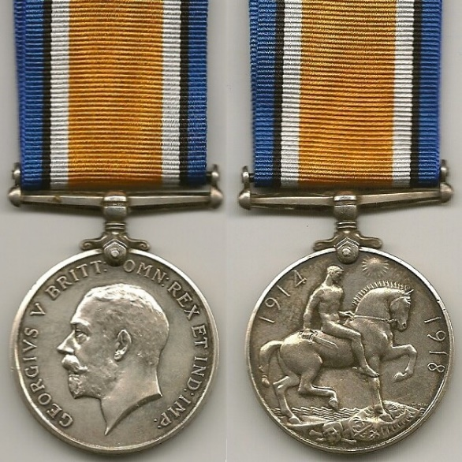
BRITISH WAR MEDAL
Established on 26th July 1919, this is a silver medal with an orange centred ribbon with black, white and royal blue edges. The colours have no special significance. It was introduced to record the conclusion of the War and awarded to anyone who saw service at any time between 1914 and 1918. The obverse shows the uncrowned profile of King George V. The reverse shows St George on horseback trampling underfoot a shield in the form of an eagle, symbolising of the German and Austro-Hungarian Empires . There is also a skull and crossbones – the emblem of death. Above St George, the sun has risen in victory. Some 6.5 million silver medals were issued. James Marsh’s service number, rank, name and unit are inscribed on the rim.
ALLIED VICTORY MEDAL
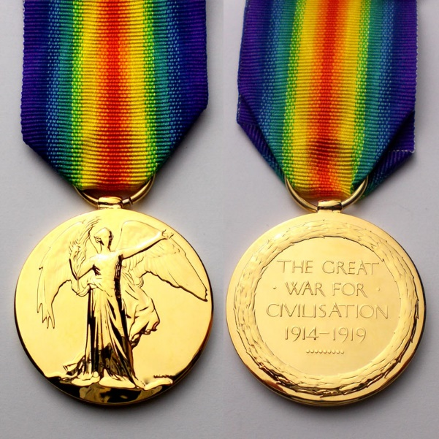
The Allies issued their own bronze victory medal with a similar design, equivalent wording and identical ribbon. The ribbon consists of a double rainbow with red at the centre and reflects the colours of the Allies, with the rainbow representing the calm after the storm. This yellow bronze medal was awarded to all those who had received the Star medals and most of those who had received the British War Medal. The obverse has the standing figure of Victory holding a palm branch in her right hand and on the reverse a laurel wreath contains the inscription “THE GREAT WAR FOR CIVILISATION 1914-1919”. The extended date reflects the continued fighting in India and Russia and the Peace Treaty at Versailles in June 1919. Approximately 6 million medals were produced. James Marsh’s service number, rank, name and unit are inscribed on the rim.
MEMORIAL PLAQUE
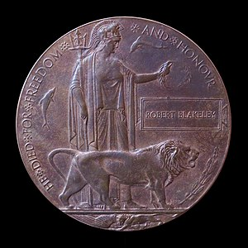
This was issued after the First World War to the next-of-kin of all British Empire service personnel killed as a result of the war. Some 120 mm diameter, cast in bronze, it became known as the Dead Man’s Penny, because of the similarity in to a penny coin. About 1.3million were issued, using 450 tons of bronze. The design has Britannia holding a trident standing with a lion. Her outstretched left hand holds an olive wreath. Right of the lion, is an oak spray with acorns. Two dolphins swim round Britannia, symbolising Britain's sea power and at the bottom a second lion is tearing apart the German eagle. The legend reads "HE DIED FOR FREEDOM AND HONOUR”. Above the lion is a rectangle bearing James Marsh’s name. It does not include the rank since there was no distinction drawn between the sacrifices made by different individuals. The reverse side is blank.

