Great Bradley Church, Suffolk: Grave Number 90

Ronald Percival Lawrence Smith

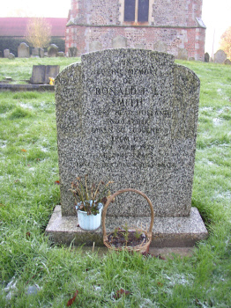 | In  Loving Memory  of  Ronald.P.L  Smith  A Very Dear Husband  and Father  Taken So Suddenly  From Us  10 April 1978  Aged 46 Years  Love Is Not Changed By Death  The is a footstone engraved 'E.H 1905'

