Great Bradley Church, Suffolk: Grave Number 8
Clement (Clem) Smith

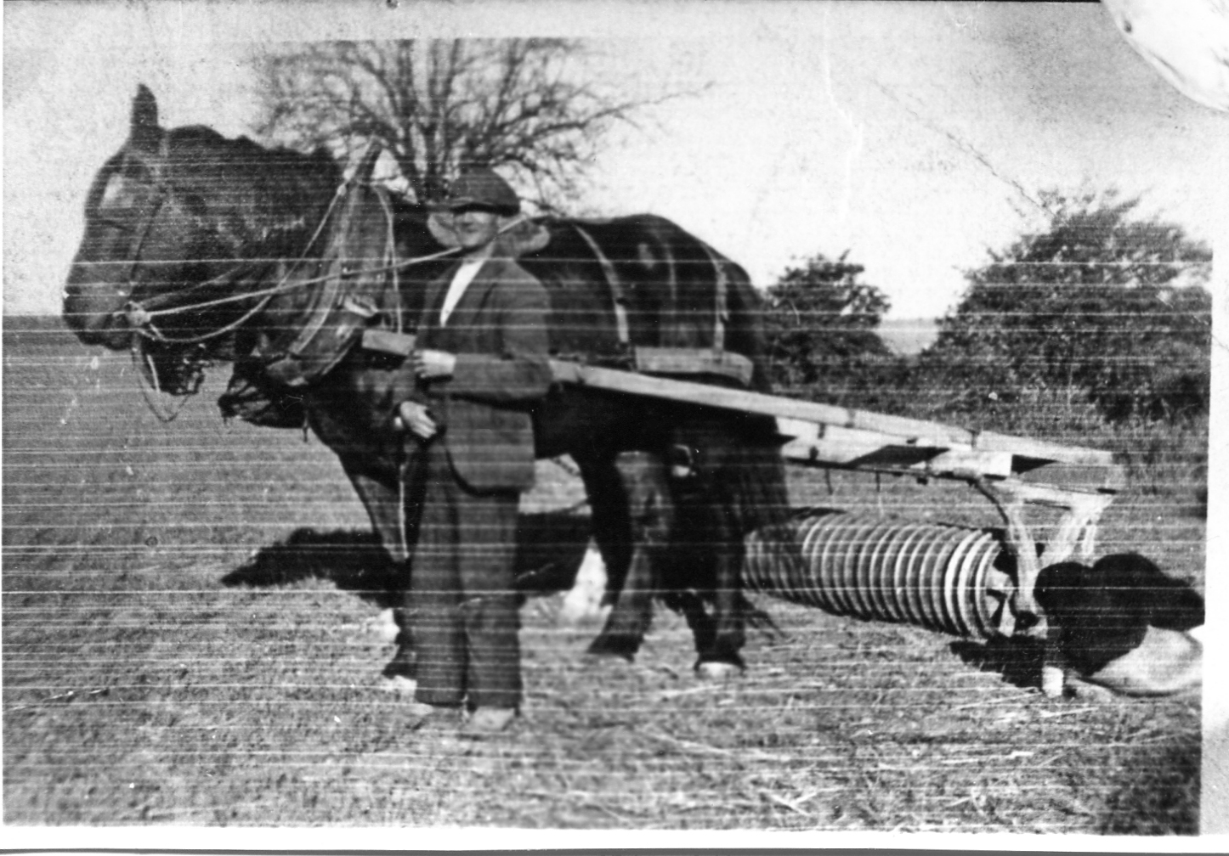  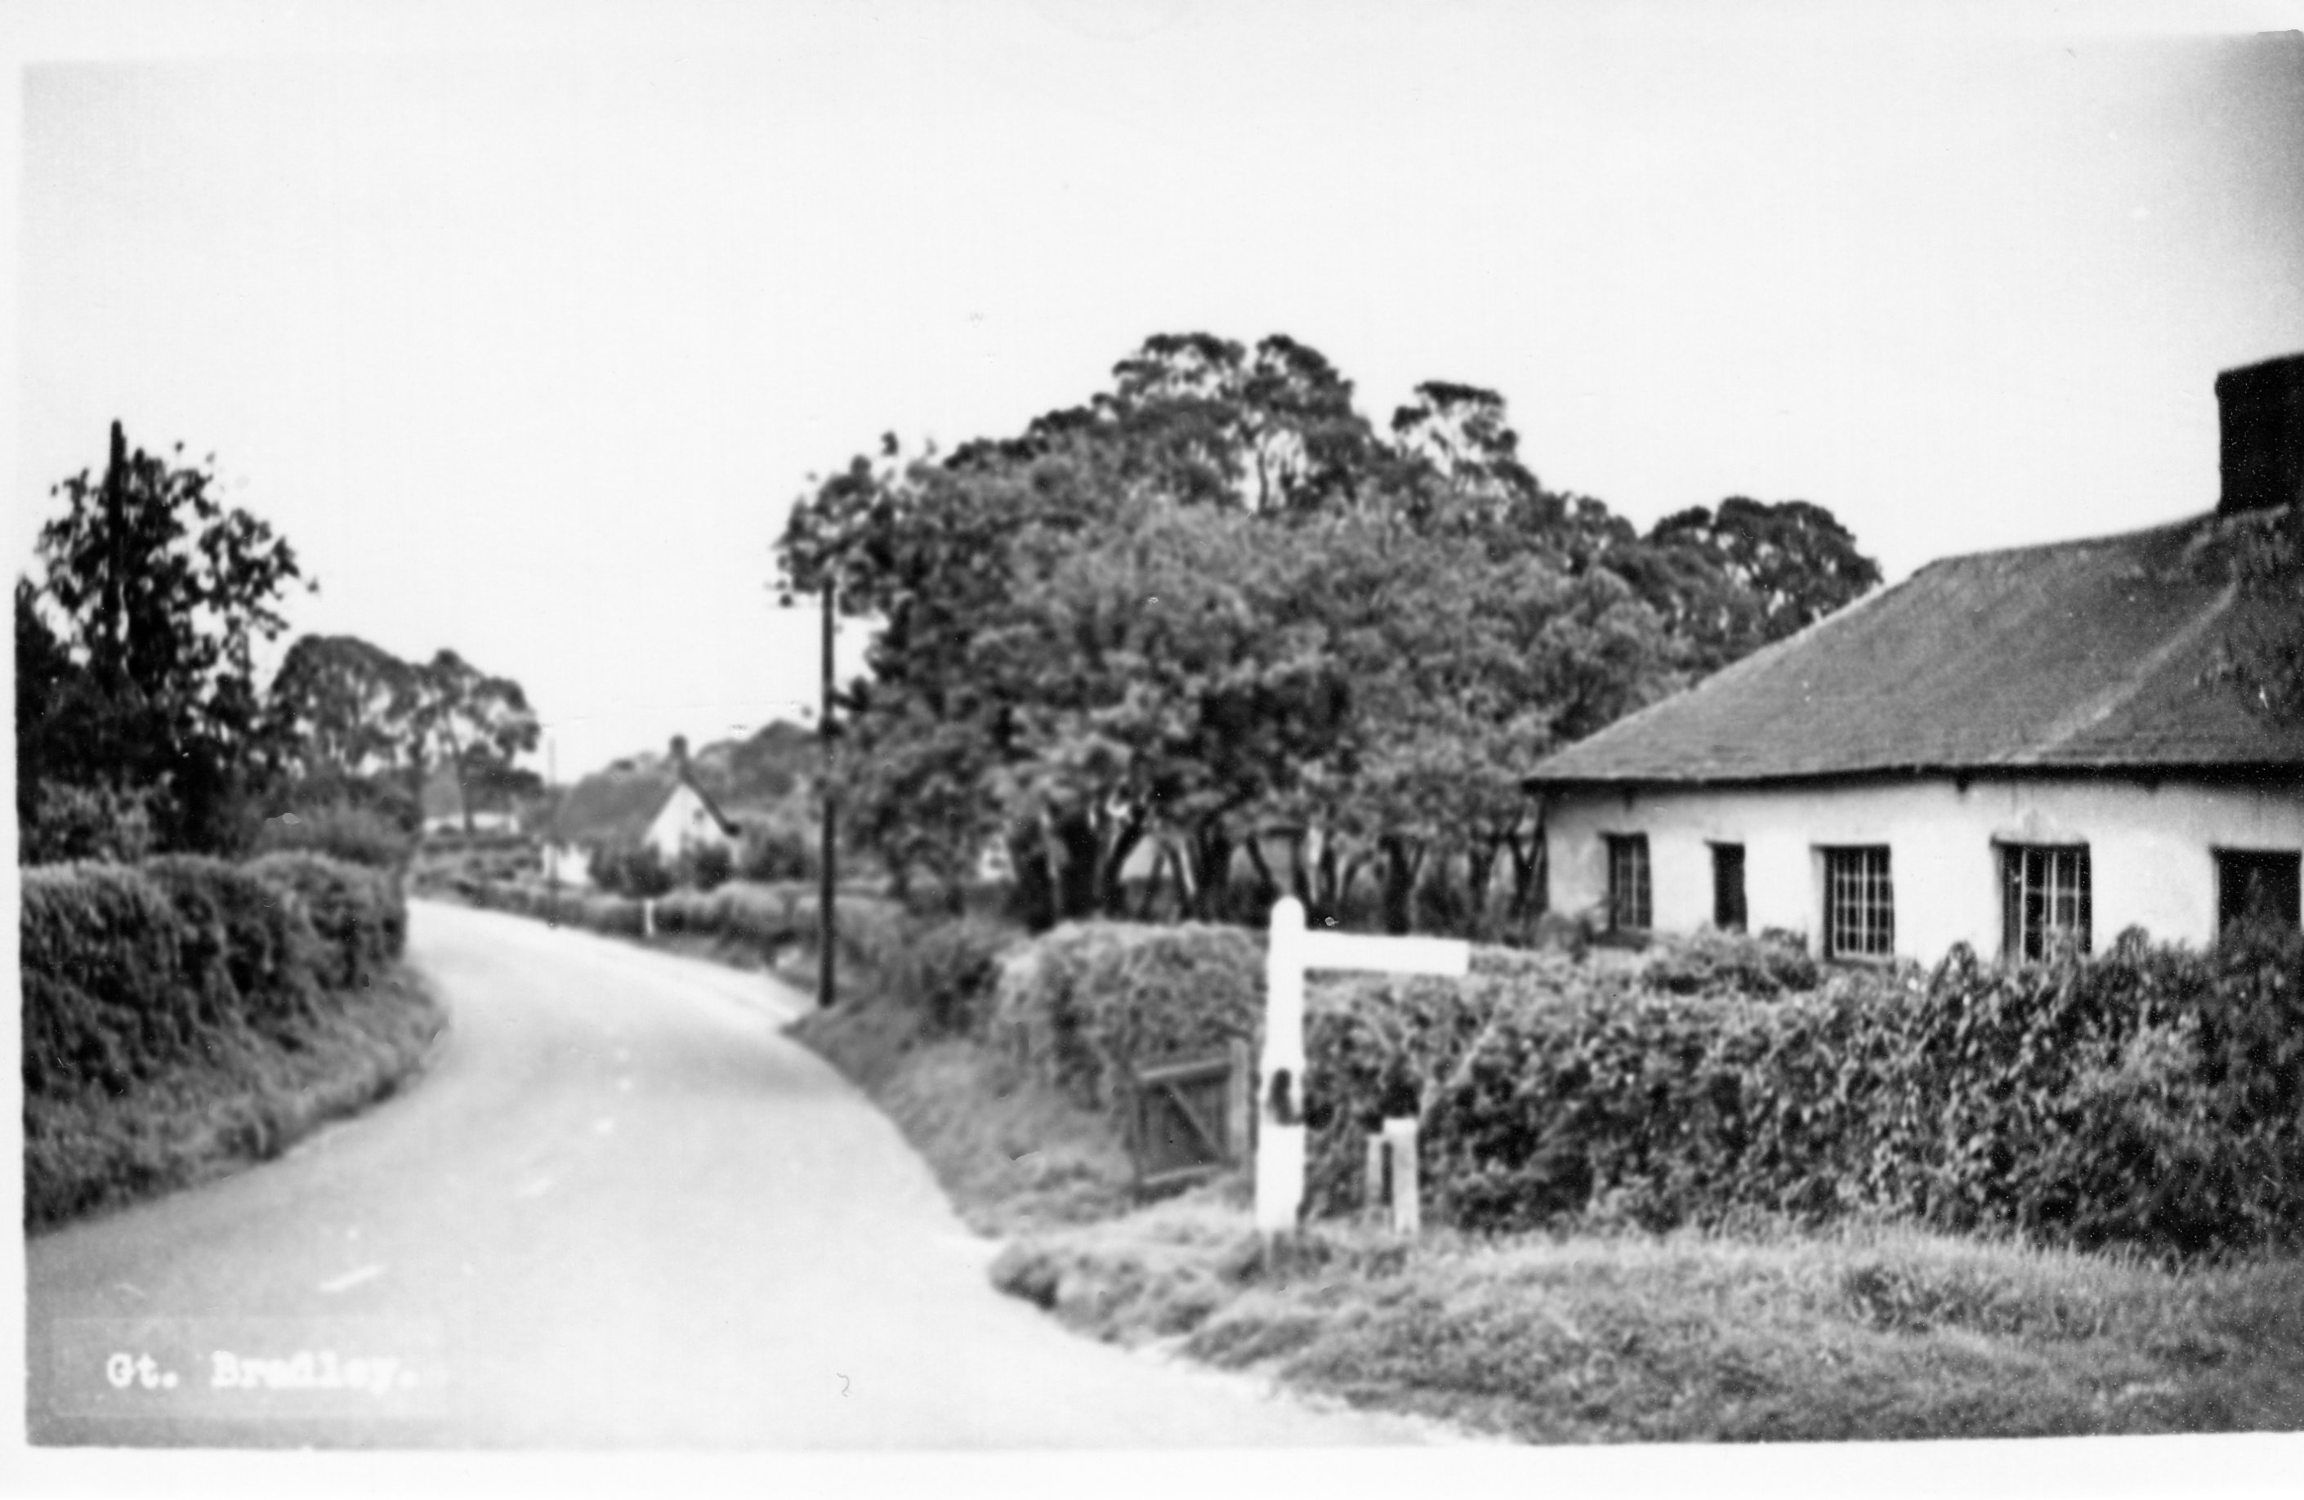  Clem Smith's house was on the main street | No gravestone  1984 & 1987 plan & notes & Burial register P12, Feb 1973 confirms the grave

