Great Bradley Church, Suffolk: Grave Number 84
Nathan William Gooch
Nathan William Gooch, died 1956. He was the blind publican of the Fox public house and able to differentiate between a old ten shilling note and a one pound note by running them through his fingers.

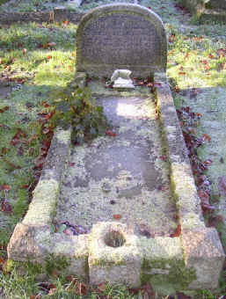 | CHERISHED MEMORIES  OF  A DEVOTED HUSBAND  NATHAN WILLIAM GOOCH  WHO DIED 8TH DEC 1956  AGED 70 YEARS  AT REST
