Great Bradley Church, Suffolk: Grave Number 82
John Ian Scovell Martin

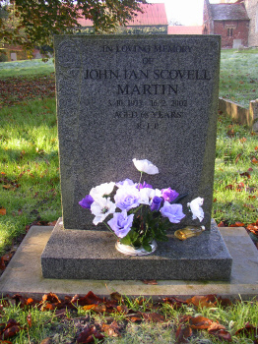 | IN LOVING MEMORY OF  JOHN IAN SCOVELL  MARTIN  3.10.1993 - 16.2.2002  AGED 68 YEARS  R.I.P
