Great Bradley Church, Suffolk: Grave Number 78

Ethel Hayward
Ethel was Daughter of Richard and Sophia, See Grave No. 79
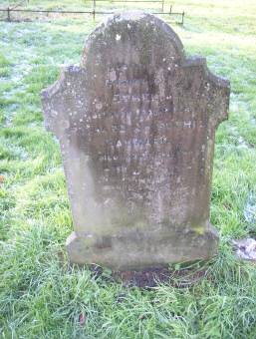 | In  Loving  Memory of  Ethel  The Beloved Daughter of  Richard & Sophia  HAYWARD  Who died July 15th 1905  Aged 17 Years  'Nearer My God to Thee  Nearer to Thee'  The is a footstone engraved 'E.H 1905'
