Great Bradley Church, Suffolk: Grave Number 12
Leslie A Reed and Alice D Reed
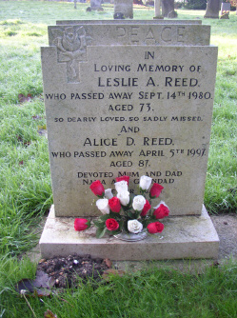 | PEACE  IN  LOVING MEMORY OF  LESLIE A REED  WHO PASSED AWAY SEPT 14TH 1980  AGED 73  SO DEARLY LOVED SO SADLY MISSED  AND  ALICE D REED  WHO PASSED AWAY APRIL 5th 1997  AGED 87 YEARS  DEVOTED MUM AND DAD  NANA AND GRANDAD  TOGETHER AGAIN
