Great Bradley Church, Suffolk: Grave Number 6
Ernest Phillips and Mary Phillips

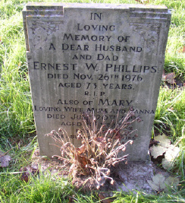 | IN  LOVING  MEMORY OF  A DEAR HUSBAND  AND DAD  ERNEST W PHILLIPS  DIED NOV 26TH 1976  AGED 73 YEARS  R.I.P  ALSO OF MARY  LOVING WIFE AND NANNA  DIED JULY 20TH 1986  AGED 85 YEARS  REUNITED  TREASURED MEMORIES
