Great Bradley Church, Suffolk: Grave Number 69

Sarah Ann Turner
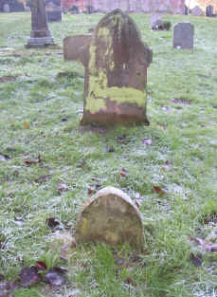 | IN AFFECTIONATE  REMEMBRANCE OF  SARAH ANN  THE BELOVED WIFE OF  ROBERT TURNER  WHO DEPARTED THIS LIFE  MARCH 12 TH 1917  AGED 65 YEARS  REST IN PEACE  The Footstone has:  S.A.T  1917
