Great Bradley Church, Suffolk: Grave Number 5
Percy Jolly
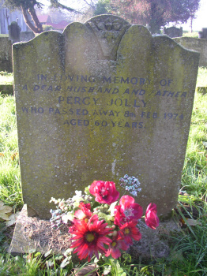 | IN LOVING MEMORY OF  A DEAR HUSBAND AND FATHER  PERCY JOLLY  WHO PASSED AWAY 8TH FEB 1974  AGED 60 YEARS
