Great Bradley Church, Suffolk: Grave Number 56
Jane Reed and Ernest Reed
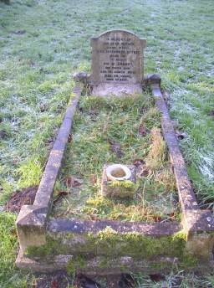 | IN MEMORY OF  OUR DEAR MOTHER  JANE REED  DIED SEPTEMBER 10 1937  AGED 70  "AT REST"  AND OF ERNEST  HER THIRD SON  DIED 25 MARCH 1964  AGED 69 YEARS  Jane Reed 1937, died in the National Temperance Hospital in London. Her third son Ernest died in 1964 in Natal and his ashes are interned here].  There is also a stone tablet on the grave showing Agnes Jane, David Reed, [no trace in burial register] and Jenny 1986 [no trace in register].
