Great Bradley Church, Suffolk: Grave Number 50

Ann Martin 1922 wife of George W Martin 1931

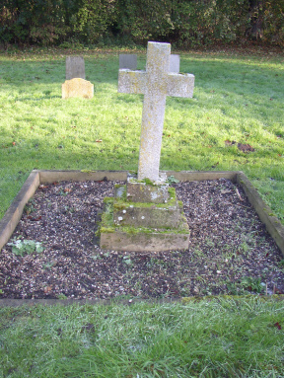 | double grave

