Great Bradley Church, Suffolk: Grave Number 48

Rose Anna Gooch
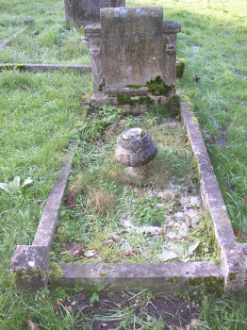 | IN  LOVING MEMORY OF  A DEAR WIFE AND MOTHER  ROSE ANNA GOOCH  WHO PASSED AWAY JUNE 2ND 1931  AGED 54 YEARS
