Great Bradley Church, Suffolk: Grave Number 44a
Martin Smith

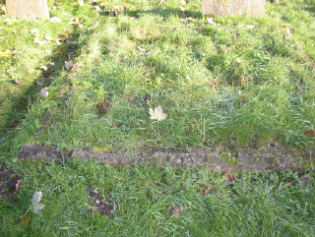 | MARTIN SMITH  DIED MARCH 11  1940  AGED 82 YEARS

