Great Bradley Church, Suffolk: Grave Number 41
Daisy Matilda Ladd and Frederick Charles Ladd

DAISY MATILDA  LADD  BORN 10TH  DECEMBER  1888  DIED  12TH JULY  1962  [on left side] | IN LOVING MEMORY  [on top side]  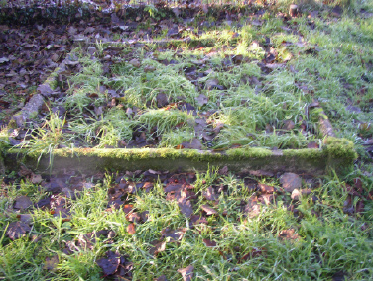  REST IN PEACE  [on lower side] | FREDERICK  CHARLES LADD  DIED 28TH  JULY 1964  AGED 75 YEARS  [on right side]

