Great Bradley Church, Suffolk: Grave Number 39
Jean Eileen Dixon
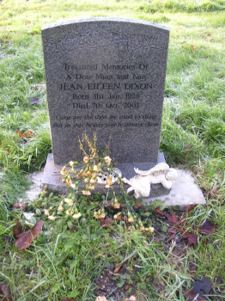 | TREASURED MEMORIES OF  A DEAR MUM AND NAN  JEAN EILEEN DIXON  BORN 31ST JAN 1928  DIED 7TH OCT 2003  Gone are the days we used to share  But in our dreams you're always there  Jean's husband, John, is buried in plot 38
