Great Bradley Church, Suffolk: Grave Number 38
John Ramsey Dixon
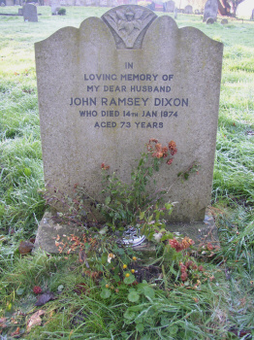 | IN  LOVING MEMORY OF  MY DEAR HUSBAND  JOHN RAMSEY DIXON  WHO DIED 14TH JAN 1974  AGED 73 YEARS  John was a local shepherd.  His first wife, Grace, is buried in plot 37 and his second wife, Jean, in plot 39
