Great Bradley Church, Suffolk: Grave Number 214

Maurice Henry Goody

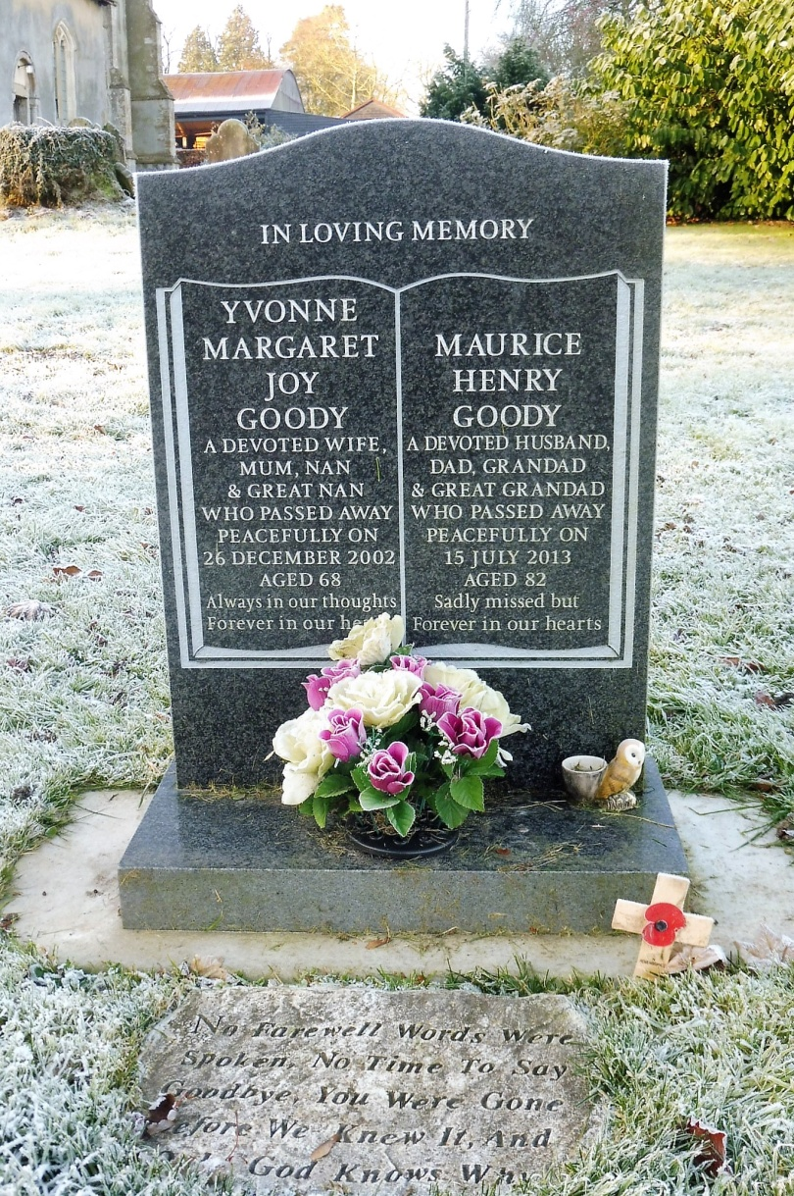
Maurice is reunited with his wife in Grave number 104
A devoted husband, dad and granddad & great granddad
who passed away peacefully on 15th July 2013 Aged 82
Sadly missed but forever in our hearts

