Great Bradley Church, Suffolk: Grave Number 212

Cyril David Potter

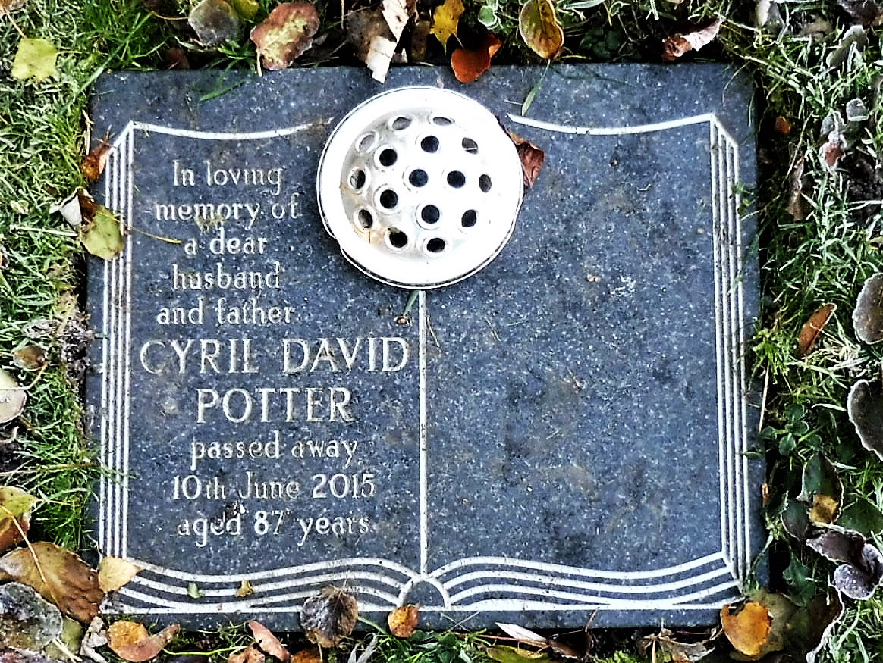
In loving memory of a dear husband and father
CYRIL DAVID POTTER
passed away 10th June 2015
aged 87 years

Provision is made for his wife, Joyce, a long time popular village resident
and parents of the local gamekeeper, Colin Potter

