Great Bradley Church, Suffolk: Grave Number 211

Betty Felton and Oswald Robert [Bob] Felton

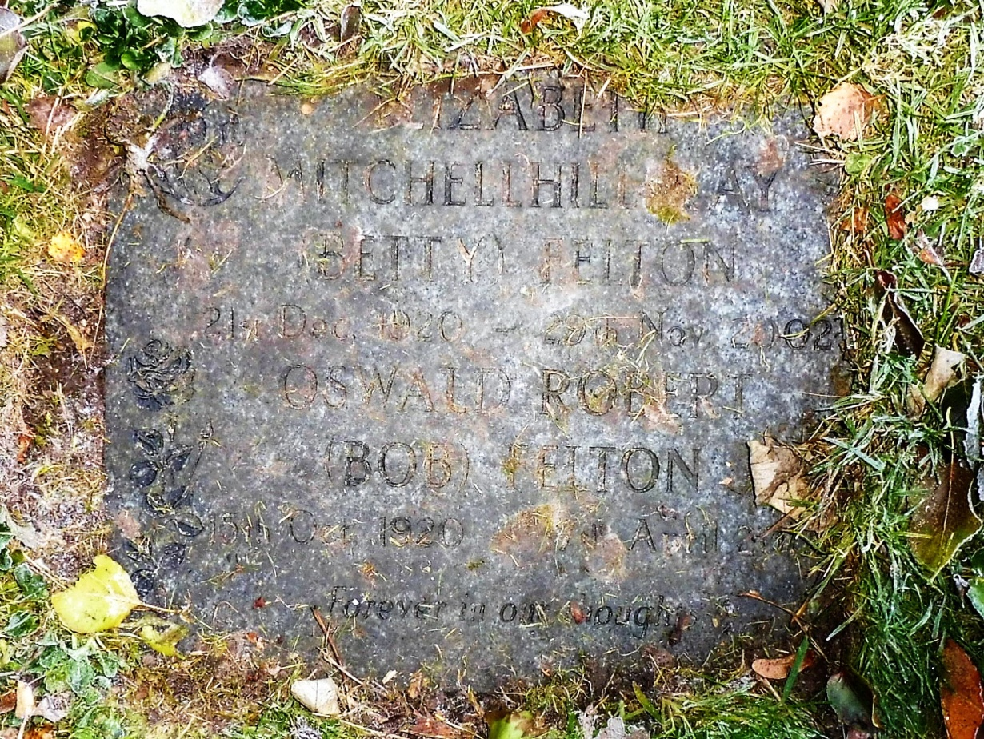
Joint cremation stone.
Betty Felton died 29 November 2002 and Oswald Robert (Bob) Felton died 7th April 212
The Felton family have a long association with the village

