Great Bradley Church, Suffolk: Grave Number 208
David Morgan Furze

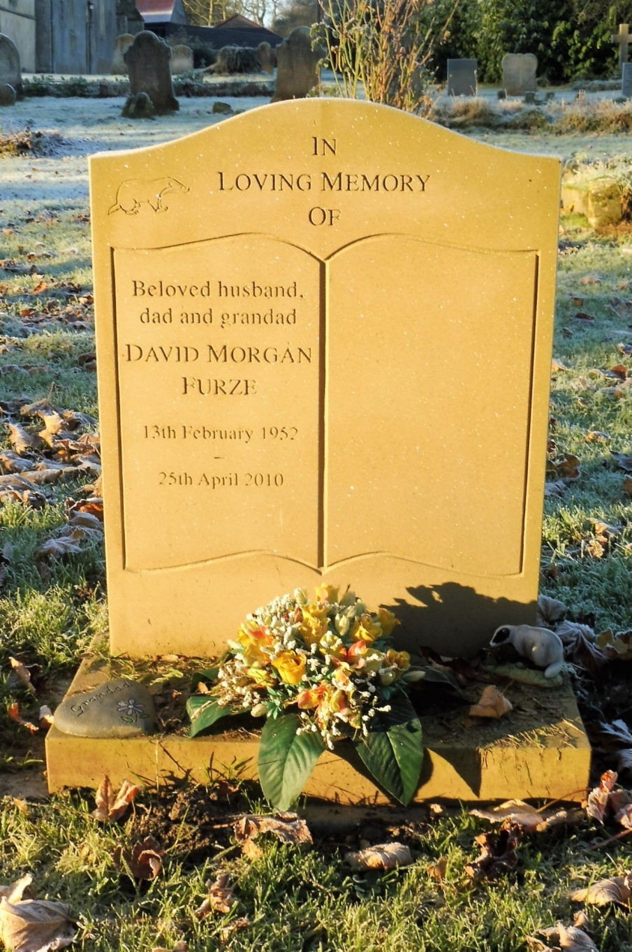 | Beloved husband, dad and grandad  DAVID MORGAN FURZE  13th February 1952 – 25th April 2010
Died 25th April 2010 aged 58 years. Lived in Woodbridge, Suffolk. Member of the Goody family also buried in the graveyard [Graves 100 and 104]

