Great Bradley Church, Suffolk: Grave Number 207
Lavena Agnes David HAWES

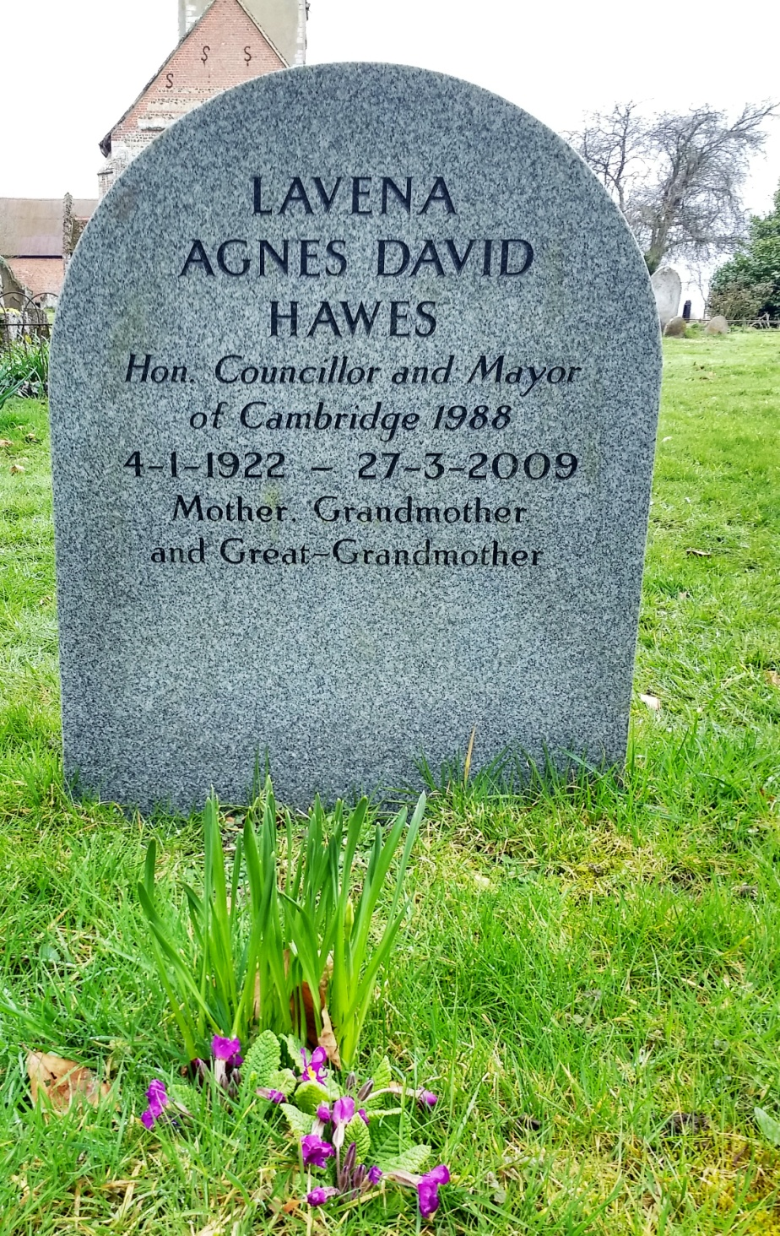 | Lavena Agnes David Hawes  Hon. Councillor and Mayor of Cambridge 1988  4-1-1992 ~ 27-3-2009  Mother, Grandmother and Great-Grandmoher

