Great Bradley Church, Suffolk: Grave Number 206
Anthony [Tony] Walter Knight

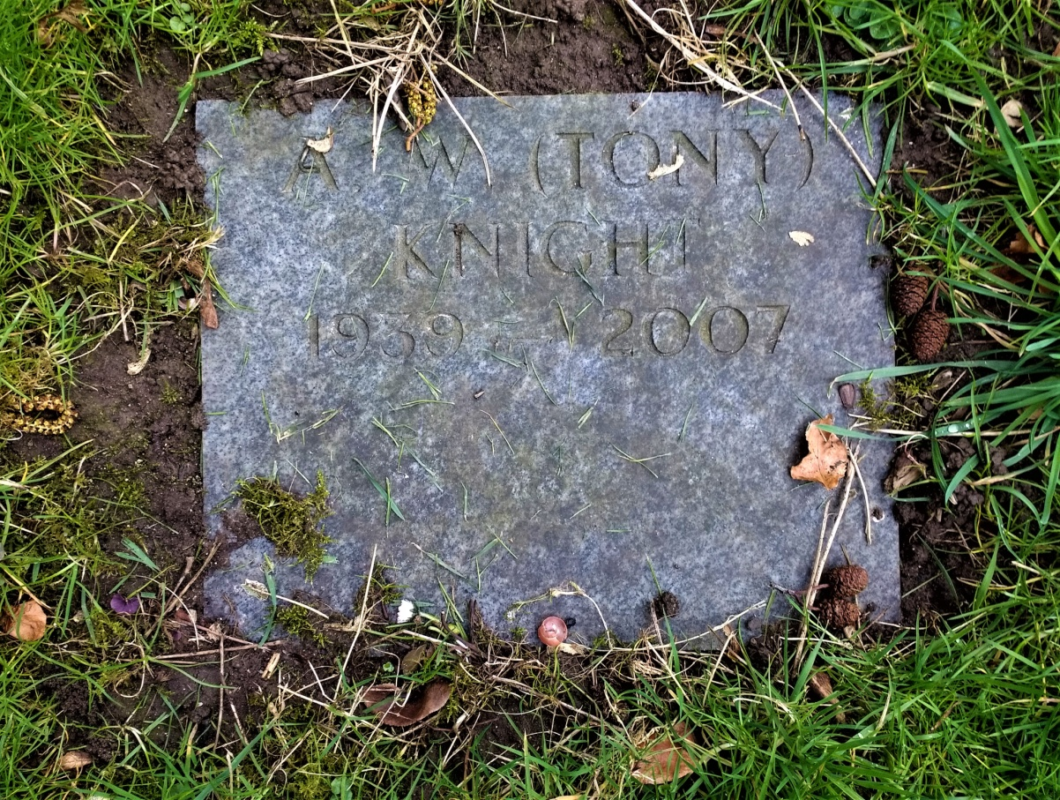
Anthony Walter Knight died 10th July 2007 aged 67 years. Husband of Marie. Lived at Crown House-previously the village Post Office and Petrol Station. Stalwart of the village for many years as Church Warden and Treasurer, Parish Council Chairman and organiser of the village fete. Much respected. A tribute to Tony appeared in the Bradley Bugle.

