Great Bradley Church, Suffolk: Grave Number 205
Victor John Durrant

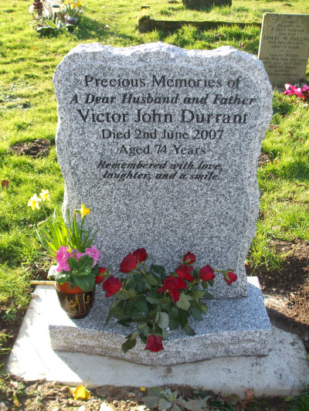 | Victor John Durrant died 2nd June 2007 aged 74 years.  Husband of Carole with whom he lived at Clarendale.  An active village member over many years. Respected Martial Arts teacher.  A tribute to Vic. appeared in the Bradley Bugle.  The grave is marked by a natural Granite memorial

