Great Bradley Church, Suffolk: Grave Number 202
Barbara Jean Buchs

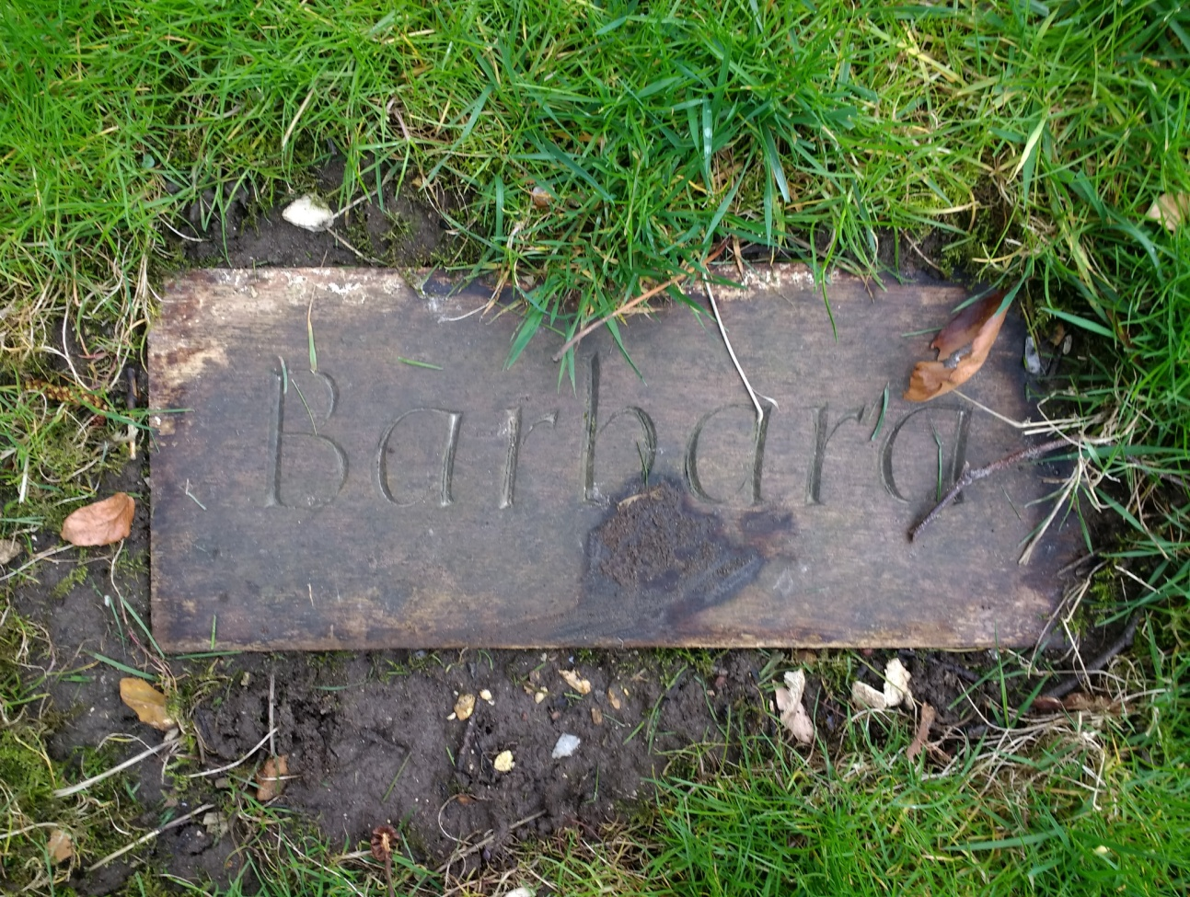

Barbara Jean Buchs died December 10th 2007 aged 69 years.
Wife of Sidney with whom she lived at Sugar Loaf. Committed to the village and past PC member, active in forming an historical record of the village, which was published in 1981 to commemorate the marriage of Charles and Diana. The information in the book formed the bedrock for the village web site. Much respected.
A tribute to Barbara appeared in the Bradley Bugle.
A Bible was presented to the Church in her memory.

