Great Bradley Church, Suffolk: Grave Number 200
Dennis Joseph Low

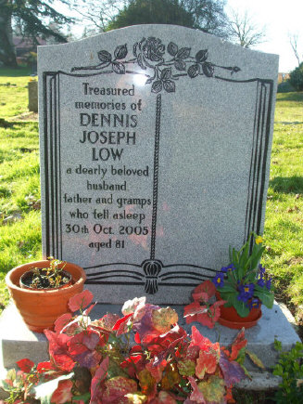 | Treasured  Memories of  DENNIS  JOSEPH  LOW  a dearly beloved husband,  father and gramps  who fell asleep  30th Oct 2005  aged 81
Dennis Joseph Low died 30th October 2005. Aged 81 years. Born 14th November1923. Husband of Clarry. Lived on Clarendale Estate. Much loved and respected in the village. Buried in a double depth grave. Polished Face Grey Memorial erected in 2006 by undertaker H J Paintin.

