Great Bradley Church, Suffolk: Grave Number 178
George and Martha Paxman
Their son is Thomas (No.177) and daughter is Liz (No. 4)

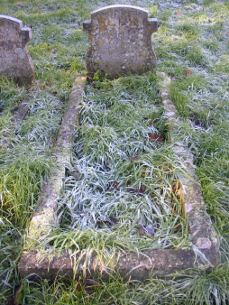 | IN LOVING MEMORY  OF  MARTHA PAXMAN  BORN 1844  DIED 1940  ALSO HER HUSBAND  GEORGE PAXMAN  THE LORD JESUS CALLED THEE

