Great Bradley Church, Suffolk: Grave Number 171
Mary Galley

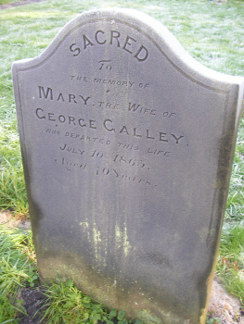

Other Galley family Graves are numbers 170,171,180

