Great Bradley Church, Suffolk: Grave Number 164
Philp Danby and his wife Ann

 | IN MEMORY OF
PHILLIP DANBY  WHO DIED 2 JUNE 1785  AGED + YEARS | 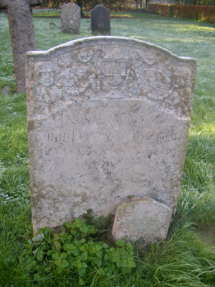 | ANN HIS WIFE  WHO DIED 28 JUNE  1780
The footstone leaning on the grave does not seem to belong. It has on it:
E T
