Great Bradley Church, Suffolk: Grave Number 163
Philp Danby and his wife Mary
SACRED
TO THE MEMORY OF
PHILIP DANBY  DIED JULY 18 1845  AGED 77 YEARS | 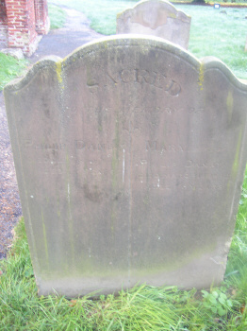  FOOTSTONE HAS  M.D F.D  1842 1845 | MARY WIFE OF  PHILLIP DANBY  DIED MARCH 1847  AGED 76 YEARS

