Great Bradley Church, Suffolk: Grave Number 153
Susanna Plumb
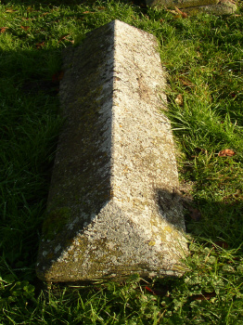 | IN LOVING MEMORY OF  SUSANNA PLUMB  WHO DIED 15TH .... 186...  AGED ......YEARS
