Great Bradley Church, Suffolk: Grave Number 152
Stephen Plumb

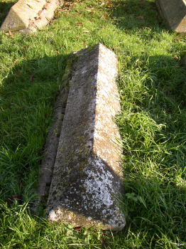 | IN LOVING MEMORY OF  STEPHEN PLUMB  WHO DIED 19TH ...... 1880  AGED 76 YEARS  [the inscription is along the length of the tomb]
