Great Bradley Church, Suffolk: Grave Number 151
Emma Susan Plumb
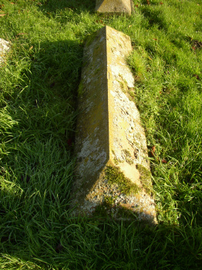 | IN LOVING MEMORY OF  EMMA SUSAN YOUNGEST DAUGHTER OF  STEPHEN PLUMB  WHO DIED MARCH 23RD 1911 AGED 58 YEARS  [the inscription is along the length of the tomb]
