Great Bradley Church, Suffolk: Grave Number 150
Ellen Plumb
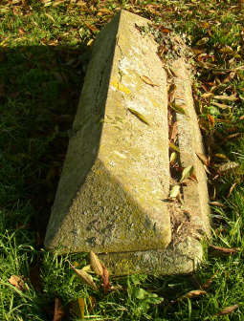 | IN LOVING MEMORY OF  ELLEN SECOND DAUGHTER OF  STEPHEN AND SUSAN PLUMB  WHO DIED DECEMBER 12TH 1911  AGED 75 YEARS  The inscription is on the long side of the tomb
