Great Bradley Church, Suffolk: Grave Number 148
Martin Plumb
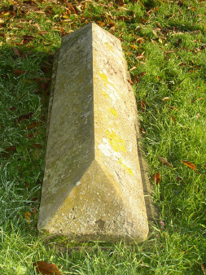 | MARTIN PLUMB THE BELOVED SON OF  STEPHEN AND SUSANNA PLUMB  WHO DIED JULY 30H 1917  AGED 72 YEARS  GONE BUT NOT FORGOTTEN  The inscription is on the long side of the tomb
