Great Bradley Church, Suffolk: Grave Number 147
Mabel Frances Wilder
Child’s Grave with Stone Cross. Mabel died at 15 days old. She was the eldest child of McMahon Charles G Wilder, Rector of Great Bradley and his wife Alice.
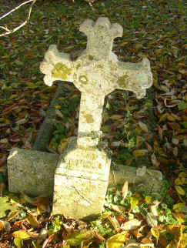 | Sacred to the memory of  Mabel Frances Eldest Daughter of  Mchn Charles Wilder, Rector of  Great Bradley and  Alice Mary, His Wife.  Born July 11 Died July 26 1870
