Great Bradley Church, Suffolk: Grave Number 141
John and Mary Paxman
Large headstone broken in three pieces and leaning against the trunk of a large Yew Tree

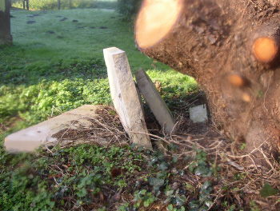 | One of the pieces is a headstone and one has a footstone. The headstone is divided down the middle and has many of the words missing but reads  SACRED  TO THE MEMORY OF  JOHN | MARY  PAXMAN | PAXMAN  WHO DIED |  1810 |  AGED 61 YEARS |  The footstone has  J P  1810  M P

