Great Bradley Church, Suffolk: Grave Number 138
Charlotte Nice

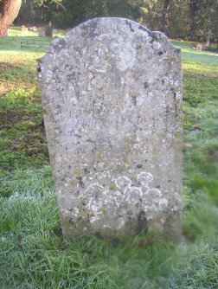 | SACRED  TO THE MEMORY OF  CHARLOTTE NICE  WHO DIED MAY 16 1871  AGED 65 YEARS  TRUTH LORDS  ......... [part eroded]
