Great Bradley Church, Suffolk: Grave Number 133
Elizabeth Nice
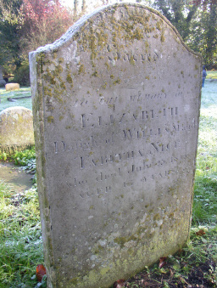 | SACRED  TO THE MEMORY OF  ELIZABETH  DAUGHTER OF WILLIAM AND  TABITHA NICE  WHO DIED JULY 25 1852  AGED 47 YEARS  Footstone has:  E.N  1852
