Great Bradley Church, Suffolk: Grave Number 130
Clarissa Nice
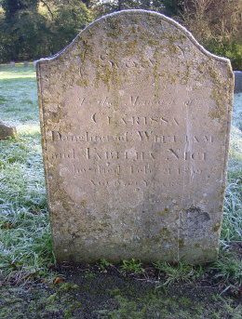 | SACRED  TO THE MEMORY OF  CLARISSA  DAUGHTER OF WILLIAM  AND TABITHA NICE  WHO DIED FEB 21st 1839  AGED 39  The footstone has  C.N
