Great Bradley Church, Suffolk: Grave Number 72

Mary Willis
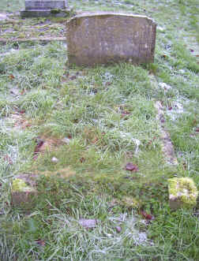 | IN  LOVING MEMORY OF OUR DEAR MOTHER  MARY WILLIS (NEE ANGUS)  WHO PASSED AWAY  OCT 26th 1941 AGED 76 YEARS  ASLEEP IN JESUS
