Great Bradley Church, Suffolk: Grave Number 126
Henry Josiah Nice
Headstone and footstone present
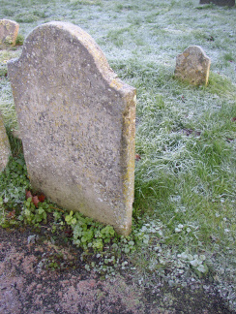 | SACRED  TO THE MEMORY OF  HENRY JOSIAH SON OF  JOSIAH AND MARY NICE  WHO DIED MAY 13 1867  AGED 23 YEARS

