Great Bradley Church, Suffolk: Grave Number 125
William Cowans and Isabella Cowans
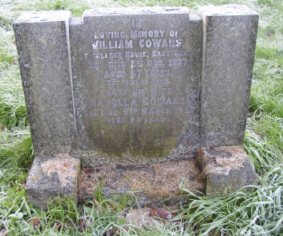 | IN  LOVING MEMORY OF  WILLIAM COWANS  OF COLLEGE HOUSE EAST GREEN  WHO DIED 2ND SEPTEMBER 1937  AGED 67 YEARS  THY WILL BE DONE  ALSO OF HIS WIFE  ISABELLA COWANS  WHO DIED 9TH MARCH 1951  AGED 83 YEARS
