Great Bradley Church, Suffolk: Grave Number 122
John Crick and Ada Crick
The book style memorial has John mentioned on the left and Ada on the right with an inscription on the outside of the lower kerb. The book is tilted at 25 degrees.

IN LOVING MEMORY OF  A DEAR HUSBAND  AND FATHER  JOHN CRICK  WHO DIED  SEPT 18TH 1933  AGED 61 YEARS  (on the left) | 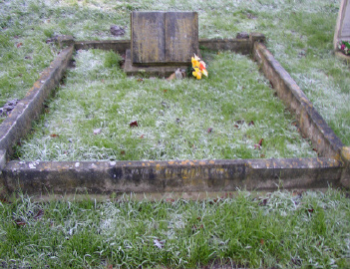  UNTIL THE RESURRECTION MORNING  (on the lower kerb) | ALSO  OF  A DEAR  MOTHER  ADA CRICK  WHO DIED  NOV 16TH 1966  AGED 83 YEARS  (on the right)

