Great Bradley Church, Suffolk: Grave Number 115

John Trafalgar Wilder,
Rector of this Parish 1881 - 1892.

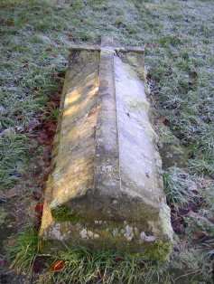
This plaque is on the north wall of the Chancel inside the church, and is one of a line of four that commemorates the fact that four Wilder brothers were consecutively Rectors of this Parish

