Great Bradley Church, Suffolk: Grave Number 103
Frederick Underwood

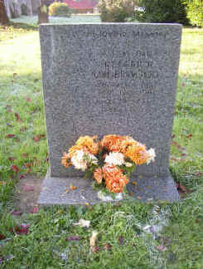 | IN LOVING MEMORY  OF  A DEAR DAD  FREDERICK  UNDERWOOD  WHO PASSED AWAY  24TH JUNE 1983  AGED 78 YEARS  REST IN PEACE
