Great Bradley through the Ages: 6. The Late Middle Ages – Part d: The Church Bells
In a slight diversion from the historical timeline that we have been following I think it is worth looking at the three bells in the church tower as they were made between the 14th and 16th Century. The tower was built in the 14th Century and the oldest bell is from the same period, about 1310, but the youngest is from 1575, when Queen Elizabeth I was on the throne.
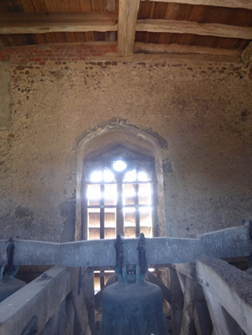
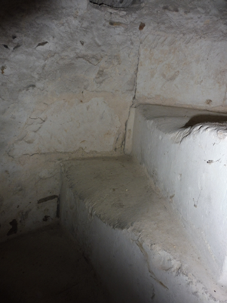
A stone spiral staircase leads from the base of the tower to the ringing chamber and on up to the roof.
The chamber is about 13 ½ feet square with an oak-beamed roof and is illuminated on three sides by glassless windows.
The bells are suspended from an elm beam fixed to an oak frame. The bells are known as being ‘hung dead’ because they do not swing and the beam is called a ‘deadstock’. If the bells are swung it is known as a ‘headstock’. The frame is 10 inches in diameter, runs East-West and is set into the walls of the tower.
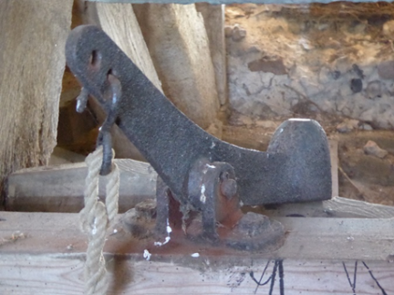
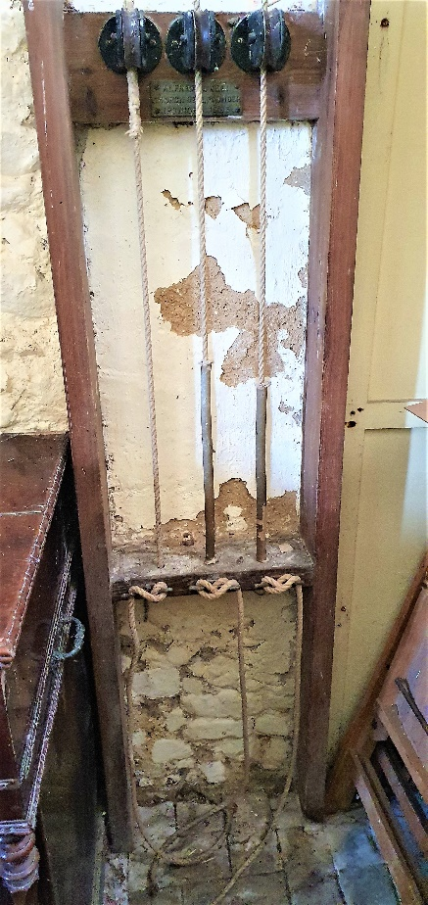
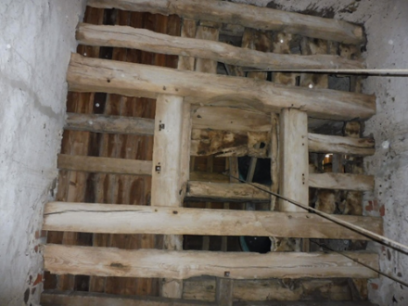
The bells are rung by iron hammers hitting the outside of south side of the bells. The hammers are moved by pulling on ropes that link the hammer to the ‘bell-pull’ in the base of the tower. To enable this, the ringing chamber floor is slatted so that the ropes can pass through.
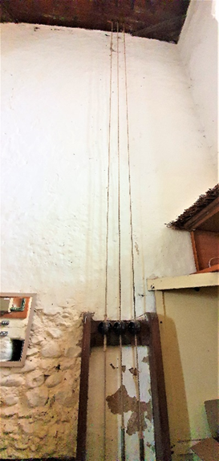
The bell-pull in the base of the tower is on the south side and this one was installed in 1935 by Alfred Bowell, bell founder and hanger in Ipswich. Pulling on the ropes lifts a hammer and when the rope is released the hammer strikes the bell to chime. The musical notes of the three bells are A-, B+ and C sharp.
Maintenance on the bells took place, in 1935 by Bowell’s of Ipswich and by the Diocesan Inspector, Ranald Clouston in 1961 and 1981/82.
The inspections found the bells and the ringing chamber in reasonable condition considering they are 500 - 700 years old! The main changes were to ensure that the hammers hit the thickest part of the bell, treating the wood to prevent beetles and adjusting some of the fixings.
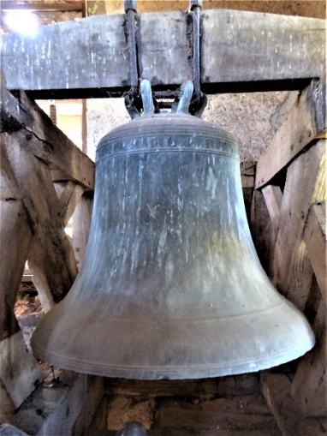
It is thought that the tenor bell was cast in about 1310, and certainly between 1290 and 1315. It weighs over 7 hundredweight, is over 35 inches in diameter and the musical note is A-.
This bell almost certainly dates from the early years of the 14th century and at about 700 years old is one of the oldest church bells in the country. It is certainly one of the three oldest church bells known in Suffolk (the oldest is probably at Hadleigh, dated to around 1280, with the oldest surviving bell in England being from 1219).
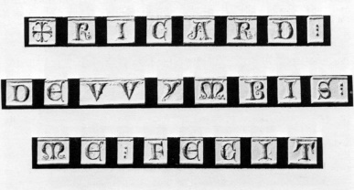
The bell in St Mary’s was made by Richard de Wymbis of London, who was known to have been working as a bell founder by 1290. Wimbish is a small village 17 miles away near Saffron Walden, which is probably where he was born. There is an inscription cast round the top of the bell inscribed 'RICHARD DE WYMBIS ME FECIT' meaning ' Richard De Wimbis made me'. Only five of his bells remain in the whole country and the one in St Mary’s is the largest.
The second bell dates from 1576. It weighs over 6 hundredweight, is 33 inches in diameter and the note is B+. It has an inscription stating it was made in Bury St Edmunds by the Stefanyz [Stephen] Tonni workshop, which established in 1570.
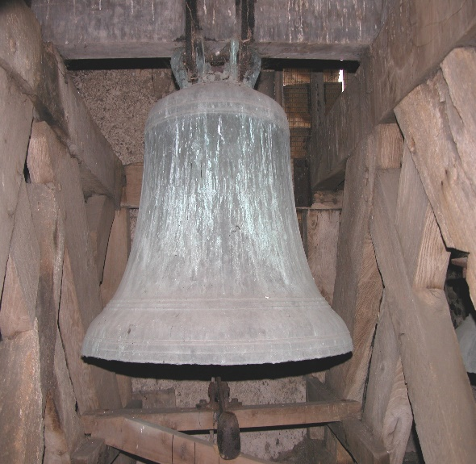
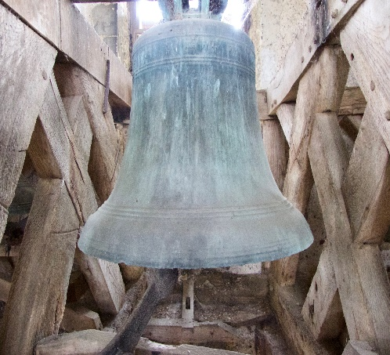
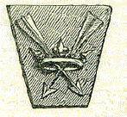
The inscription on the bell reads “ De Byri Zanti Edmondi Stefanz Tonni. Me Fecit WL 1576” meaning “From Bury St Edmunds. Stephen Toni made me in 1576”. W.L. stands for William Land who was foreman at the Tonni factory and so is acknowledged as the founder (maker) of the bell. The inscription also has the motif of a pair of arrows through a crown. This is the crest of St Edmund and was the Tonni foundry mark (and now features on the flag of Suffolk). The church at nearby Woodditton has two bells made by the same foundry, one of which was previously in Westly Waterless church until the round tower collapsed in 1855.
The third bell, the treble bell, bears no inscription and the foundry is unknown, but authorities claim that this is almost certainly a pre-Reformation bell (i.e. pre 1540) but, according to one of the repairers, no older than 1300. It weights over 5 hundredweight, is over 30 inches in diameter and the note it rings is C sharp.
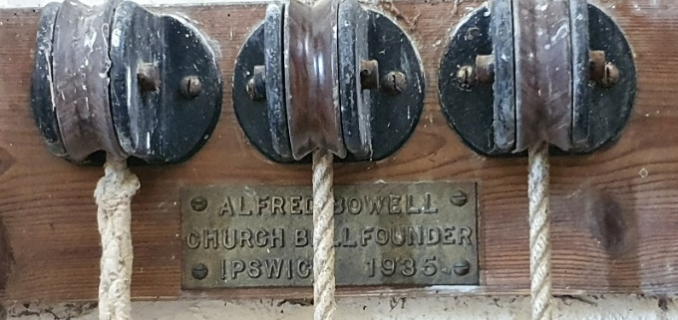

It is quite fantastic that the bells of St Mary’s survive and, even better, that after 700 years they are still calling people to services in this quiet corner of the world.
There’s more information the village website at https://greatbradley.weebly.com/church-bells.html and you can support the Friends of Great Bradley Church at https://greatbradleychurch.com/

