Great Bradley through the Ages: 5. The Normans – Part b
I am indebted Wendy Barnes of Little Bradley for the background research used in this piece. She has generously shared her knowledge and expertise.

Domesday entry for land in Bradley given to Robert of Tosny
In the last chapter we learned that the five packets of land in (what was then known as) Bradley were taken from the Saxon lords by 1071 and divided up between St Edmundsbury Abbey and two Normans, Robert de Tosny and Richard son of Count Gilbert. So how did Bradley split to form Great & Little Bradley?
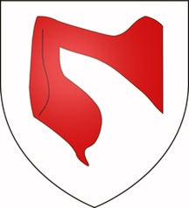
The largest and most valuable parcel of land was taken from the Saxon lord Ulf (son of Manni Swart) and given to the Richard de Tosny. It contained a church which, as there is no evidence of a Saxon church in present day Great Bradley, is assumed to have been in present day Little Bradley - which even today has evidence of its Anglo-Saxon origins.
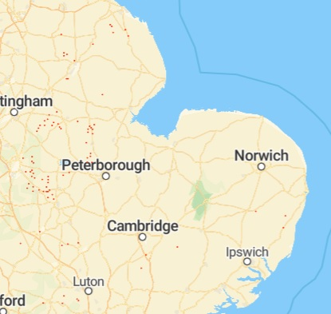
Most of Robert de Tosny’s land was in the East Midlands and he built the first Belvoir Castle (where, tradition has it, Afternoon Tea was first introduced to Britain in the 1840s). De Tosny may not even have visited this area, but it was his land that became the core of what is now Great Bradley. The exact area is unknown but The Domesday Book says that the length of de Tosny’s landholding is “one league” which, at 1 ½ miles, is about the distance between (present day) Little Bradley church and Great Bradley church.
The de Tosny Coat of Arms
Richard, son of Count Gilbert was given land in Thurlow as well as in three packets of land in Bradley (from the Saxons Whitgar, Bondi and the Abbey of St Edmundsbury). He came over at the Conquest and made his initial fortune from land gifted to him in Kent. He became one of William-the-Conqueror’s close advisers.
Manors held by Richard de Tosny

Richard took land from the thegns (Saxon Lords) in 26 out of the 33 parishes in the Risbridge Hundred (the Anglo-Saxon administrative area which included Great Bradley and stretched approximately from Moulton to Chedborough to Haverhill). Unlike Robert de Tosny, Richard had over half of his land in East Anglia. Indeed he later became known as Richard de Clare after he funded the re-founding of the priory at Stoke-by-Clare, just 9 miles away. Richard or his successors (because he retired to a monastery in 1087 and died a few years later), therefore probably had good reasons to invest in their Suffolk lands and they built a new hall on one of their land-holdings in Bradley. It was probably the building of this hall that prompted the split into the two Bradleys.
The hall was originally called Over Hall (Over means ‘Bigger’ and the current building is now called Norley Moat and is an Airbnb) and was built on the land Richard had been given. As Ulf’s hall and lands, including the church, had been given to Robert de Tosny it meant that the de Clare’s new hall and the land around it did not have a church associated with it. His land in the Thurlows did - because the churches there existed at the time of the Domesday Book. So it is possible that Richard de Clare wanted a church to go with his new hall and that by land-swap, purchase or seizure that part of Ulf’s former land containing the church was transferred from de Robert de Tosny to de Clare.
No record have yet been discovered to explain exactly what happened but, as the rest of Ulf’s former land remained with de Tosny, a new church, and probably a hall, would then have been built in present day Great Bradley and thus two ‘manors’ with separate halls and churches were created – Great and Little Bradley. The map tries to give an idea of the land involved.
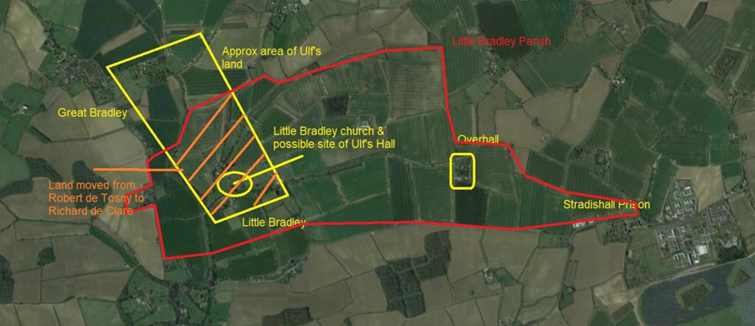
Possible land holdings in the late 11th Century leading to the formation of the two Bradleys
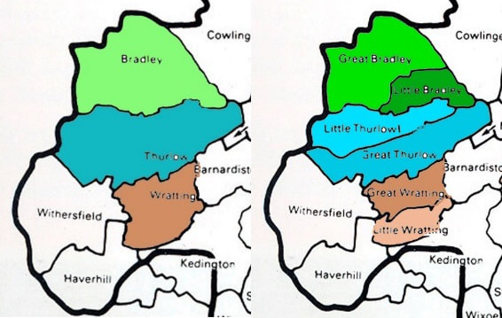
We know that the split had happened by 1174 because there are charters from this period that refer to Little Bradley, but it was probably earlier because sometime between 1100 & 1150 two men are recorded as giving their rights in Little Bradley to the priory in Stoke-by-Clare. If these dates are used, the split happened some 30 - 80 years after the Normans took over land in the area.
Latin would have been the formal language used and the two villages would have been known as Bradley Magna (Great) and Bradley Parva (Little). The use of Bradley Magna persisted as the name of the village on maps until the 19th Century.
Richard de Tosny’s land in Great Bradley soon passed to the Bigods, a powerful Norman family who built Framlingham Castle, through the marriage of his daughter Alice, who had inherited the manor of Great Bradley. She married Roger Bigod (or Bigot, died 1107) who had six lordships in Essex, 117 in Suffolk and 187 in Norfolk. Their son would become the 1st Earl of Norfolk.
Before and after maps showing the split of Bradley
NB. The two churches in Thurlow & Wratting were recognised in the Domesday Book and so a split similar to the Bradleys did not happen
The de Tosnys or the Bigods would therefore have been the ones responsible for the building of the first church for Great Bradley, which was begun in the early 12th century (1100s), and we will look at this next time.

